

Assessment Cover Page

Giovana Froelich
Student Number 2024091
Machine Learning

Assessment Due Date: | March 20, 2024
Date of Submission: | April 21, 2024
Declaration
By submitting this assessment, I confirm that I have read the CCT policy on academic misconduct and understand the implications of submitting work that is not my own or does not appropriately reference material taken from a third party or other source.
I declare it to be my own work and that all material from third parties has been appropriately referenced.
I further confirm that this work has not previously been submitted for assessment by myself or someone else in CCT College Dublin or any other higher education institution.

T

Dataset chosen: Online Education System
This dataset provides a basic overview of the online education system in India.
The dataset includes various factors such as gender, home location, level of education, age, device usage, economic status, family size, internet accessibility, sports involvement, elderly care, sleep patterns, social media usage, gaming interests, study environment, group studies, academic performance, online interaction, doubt clarification, learning preferences, and satisfaction levels.

Introdution
Understanding customer satisfaction is very important for business nowadays, satisfied customers contribute to a good company's reputation and will lead to repeat purchases. Linking with the chosen set of data we can use classification algorithms to achieve my goal of this analysis which is to models that can predict whether a customer is satisfied or dissatisfied based on the attributes.

Justification of Project Goals using Classification Algorithms
Classification Algorithms: Classification algorithms, such as random forests, logistic regression and support vector machines, are good at categorizing customers into satisfaction classes (e.g good, average, bad). By training these models on label data, they can learn to distinguish between different satisfaction levels based on input features.
I'll start importing necessary Python Libraries
In [1]:
import pandas as pd
import numpy as np
import seaborn as sns
import matplotlib.pyplot as plt
from sklearn import metrics
from sklearn import tree
from sklearn.model_selection import train_test_split
import warnings
warnings.filterwarnings('ignore')
In [2]:
df=pd.read_csv('ONLINE EDUCATION SYSTEM.csv')

Exploratory Data Analysis (EDA)
"Exploratory data analysis (EDA) is used by data scientists to analyze and investigate data sets and summarize their main characteristics, often employing data visualization methods".(IBM,2020)
After downloading the CSV file I chose, I'll use Pandas' CSV read function, so I can get a general idea of ​​our dataset by calling the first 5 rows with the head function in the next sept.
In [3]:
df.head()
Out[3]:
 | Gender | Home Location | Level of Education | Age(Years) | Number of Subjects | Device type used to attend classes | Economic status | Family size | Internet facility in your locality | Are you involved in any sports? | ... | Time spent on social media (Hours) | Interested in Gaming? | Have separate room for studying? | Engaged in group studies? | Average marks scored before pandemic in traditional classroom | Your interaction in online mode | Clearing doubts with faculties in online mode | Interested in? | Performance in online | Your level of satisfaction in Online Education
0 | Male | Urban | Under Graduate | 18 | 11 | Laptop | Middle Class | 4 | 5 | No | ... | 1 | No | No | No | 91-100 | 1 | 1 | Practical | 6 | Average
1 | Male | Urban | Under Graduate | 19 | 7 | Laptop | Middle Class | 4 | 1 | Yes | ... | 1 | Yes | Yes | No | 91-100 | 1 | 1 | Theory | 3 | Bad
2 | Male | Rural | Under Graduate | 18 | 5 | Laptop | Middle Class | 5 | 2 | No | ... | 1 | No | Yes | No | 71-80 | 1 | 1 | Both | 6 | Bad
3 | Male | Urban | Under Graduate | 18 | 5 | Laptop | Middle Class | 4 | 4 | Yes | ... | 2 | No | No | yes | 91-100 | 1 | 2 | Theory | 4 | Bad
4 | Male | Rural | Under Graduate | 18 | 5 | Laptop | Middle Class | 4 | 3 | No | ... | 2 | Yes | Yes | yes | 81-90 | 3 | 3 | Both | 6 | Average
5 rows × 23 columns
Below we can see the Dtype of the resources and if the dataframe has any missing values
In [4]:
df.info()
<class 'pandas.core.frame.DataFrame'>
RangeIndex: 1033 entries, 0 to 1032
Data columns (total 23 columns):
# Column Non-Null Count Dtype
--- ------ -------------- -----
0 Gender 1033 non-null object
1 Home Location 1033 non-null object
2 Level of Education 1033 non-null object
3 Age(Years) 1033 non-null int64
4 Number of Subjects 1033 non-null int64
5 Device type used to attend classes 1033 non-null object
6 Economic status 1033 non-null object
7 Family size 1033 non-null int64
8 Internet facility in your locality 1033 non-null int64
9 Are you involved in any sports? 1033 non-null object
10 Do elderly people monitor you? 1033 non-null object
11 Study time (Hours) 1033 non-null int64
12 Sleep time (Hours) 1033 non-null int64
13 Time spent on social media (Hours) 1033 non-null int64
14 Interested in Gaming? 1033 non-null object
15 Have separate room for studying? 1033 non-null object
16 Engaged in group studies? 1033 non-null object
17 Average marks scored before pandemic in traditional classroom 1033 non-null object
18 Your interaction in online mode 1033 non-null int64
19 Clearing doubts with faculties in online mode 1033 non-null int64
20 Interested in? 1033 non-null object
21 Performance in online 1033 non-null int64
22 Your level of satisfaction in Online Education 1033 non-null object
dtypes: int64(10), object(13)
memory usage: 185.7+ KB
My objective of this analysis is student satisfaction with the online class, often student satisfaction is linked to the performance they had in online studies, now at this stage of the work I will check the relationship between online performance and my other numerical columns and I exclude those that do not have a high relationship, so as not to interfere with my machine learning module. The results furthest from 1 are the least related to my objective.
In [5]:
df2=df.select_dtypes(exclude=object)
In [6]:
df2.corr()
Out[6]:
 | Age(Years) | Number of Subjects | Family size | Internet facility in your locality | Study time (Hours) | Sleep time (Hours) | Time spent on social media (Hours) | Your interaction in online mode | Clearing doubts with faculties in online mode | Performance in online
Age(Years) | 1.000000 | -0.011505 | 0.016893 | 0.072625 | 0.005344 | -0.072031 | 0.005455 | 0.171943 | 0.125559 | 0.114965
Number of Subjects | -0.011505 | 1.000000 | 0.035997 | -0.025915 | 0.024280 | 0.051531 | 0.004833 | -0.005144 | -0.008595 | 0.012740
Family size | 0.016893 | 0.035997 | 1.000000 | -0.020996 | 0.060614 | -0.015787 | 0.053512 | -0.024268 | -0.019461 | 0.001549
Internet facility in your locality | 0.072625 | -0.025915 | -0.020996 | 1.000000 | -0.011554 | 0.051838 | 0.082772 | 0.204391 | 0.158990 | 0.257339
Study time (Hours) | 0.005344 | 0.024280 | 0.060614 | -0.011554 | 1.000000 | -0.044385 | -0.125986 | 0.148859 | 0.175169 | 0.134344
Sleep time (Hours) | -0.072031 | 0.051531 | -0.015787 | 0.051838 | -0.044385 | 1.000000 | 0.144587 | 0.032598 | 0.043402 | 0.065020
Time spent on social media (Hours) | 0.005455 | 0.004833 | 0.053512 | 0.082772 | -0.125986 | 0.144587 | 1.000000 | -0.083972 | -0.101847 | -0.086568
Your interaction in online mode | 0.171943 | -0.005144 | -0.024268 | 0.204391 | 0.148859 | 0.032598 | -0.083972 | 1.000000 | 0.723216 | 0.557507
Clearing doubts with faculties in online mode | 0.125559 | -0.008595 | -0.019461 | 0.158990 | 0.175169 | 0.043402 | -0.101847 | 0.723216 | 1.000000 | 0.561091
Performance in online | 0.114965 | 0.012740 | 0.001549 | 0.257339 | 0.134344 | 0.065020 | -0.086568 | 0.557507 | 0.561091 | 1.000000
In [7]:
df2.corr().style.background_gradient(cmap="Blues")
Out[7]:
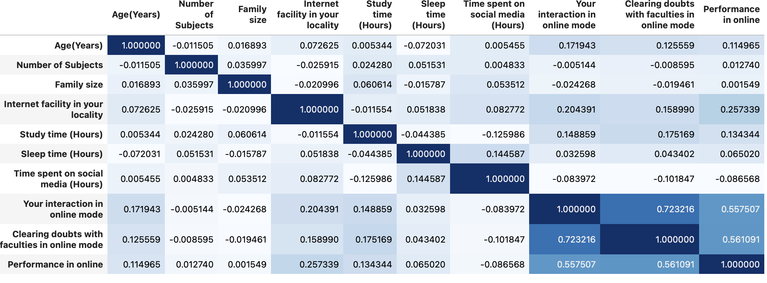
I can see that if the student has had some type of online interaction or clearing doubts with faculties, there may be some correlation with our target, as well as the number of hours they spend studying.
I'll drop the columns with less correlation with my target.
In [8]:
df3= df.drop(columns=['Time spent on social media (Hours)','Number of Subjects','Sleep time (Hours)','Family size','Are you involved in any sports?','Interested in Gaming?','Average marks scored before pandemic in traditional classroom'])
In [9]:
df3.head()
Out[9]:
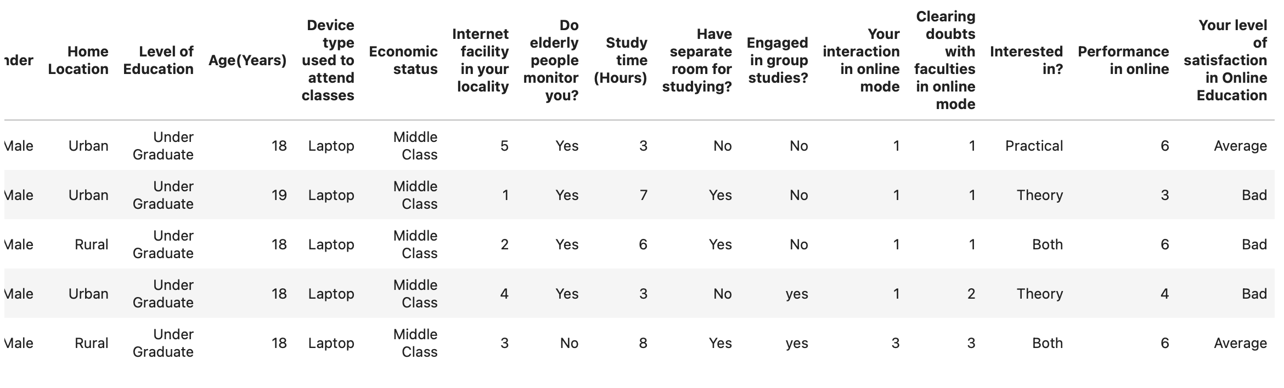Below I checked if my dataset has some null or missing values.
In [10]:
df3.isnull().sum()
Out[10]:
Gender 0
Home Location 0
Level of Education 0
Age(Years) 0
Device type used to attend classes 0
Economic status 0
Internet facility in your locality 0
Do elderly people monitor you? 0
Study time (Hours) 0
Have separate room for studying? 0
Engaged in group studies? 0
Your interaction in online mode 0
Clearing doubts with faculties in online mode 0
Interested in? 0
Performance in online 0
Your level of satisfaction in Online Education 0
dtype: int64
And now if there is some duplicated values
In [11]:
duplicated=df3.duplicated().sum()
print(duplicated)
3
So, there are 3 duplicates I'll drop them.
In [12]:
df3.drop_duplicates(inplace=True)
In [13]:
df3.shape
Out[13]:
(1030, 16)
I will rename my columns to follow a pattern and have a better understanding.
In [14]:
df3.rename(columns={'Age(Years)': 'Age','Device type used to attend classes':'Device type Used','Clearing doubts with faculties in online mode':'Clearing doubts','Your level of satisfaction in Online Education':'Level of Satisfaction','Do elderly people monitor you?':'Monitoring for the elderly','Have separate room for studying?':'Separate room for Studying','Engaged in group studies?':'Group Studies','Interested in?':'Learning Method'}, inplace=True)
In [15]:
df3.head()
Out[15]:
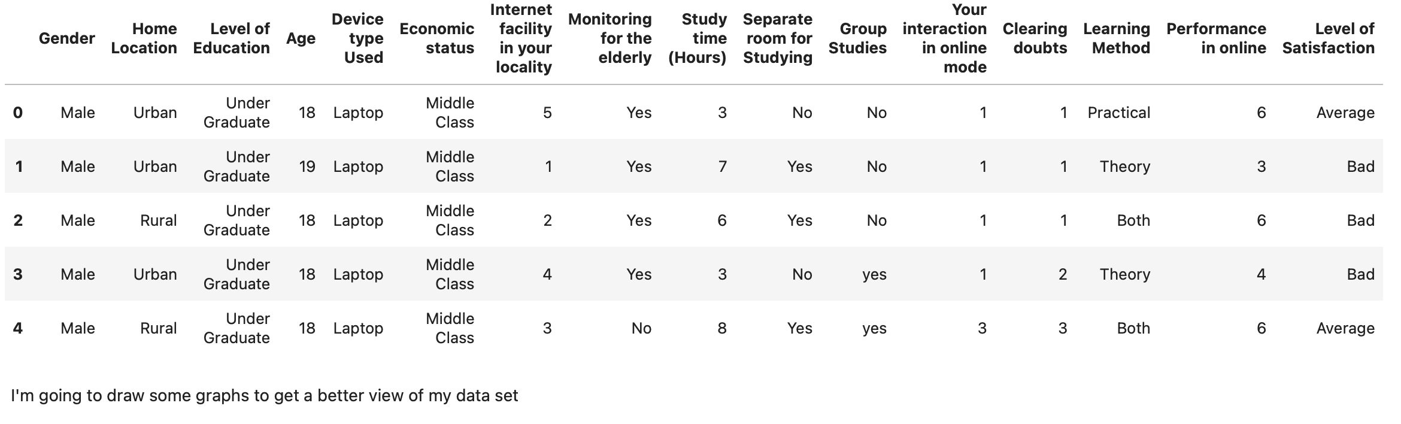I'm going to draw some graphs to get a better view of my data set
In [16]:
fig, ax = plt.subplots(1, 2, figsize=(12, 6))

df3["Level of Satisfaction"].value_counts().plot(kind="pie", explode=[0.05, 0.05, 0.05], autopct='%1.1f%%', ax=ax[0], shadow=True)
ax[0].set_title("Satisfaction Level")
ax[0].set_ylabel('')

count = sns.countplot(x="Level of Satisfaction", data=df3, ax=ax[1])
for bar in count.patches:
count.annotate(format(bar.get_height()),
(bar.get_x() + bar.get_width() / 2,
bar.get_height()), ha='center', va='center',
size=11, xytext=(0, 8),
textcoords='offset points')
ax[1].set_title("Level of Satisfaction")
plt.show()
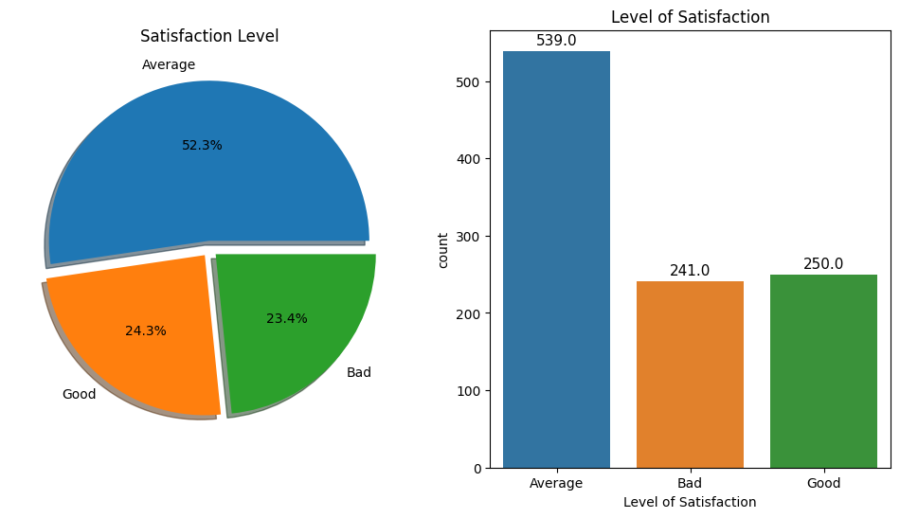
As we can see, this dataset is imbalanced.
More than 50% (539) of students in this dataset have average satisfaction, 24,3% (250) have good satisfaction, and 23,4% (241) of students have bad satisfaction in online education.
I'll try to solve this imbalanced problem before applying some machine learning model, for now, I'm just understanding my data.
In [17]:
i = 1
plt.figure(figsize = (15,25))
for feature in df3:
plt.subplot(6,3,i)
sns.countplot(x = feature , data = df3)
i +=1
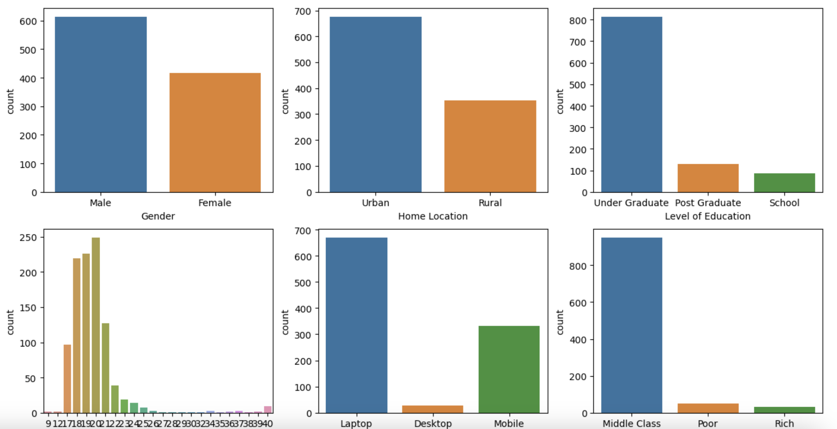
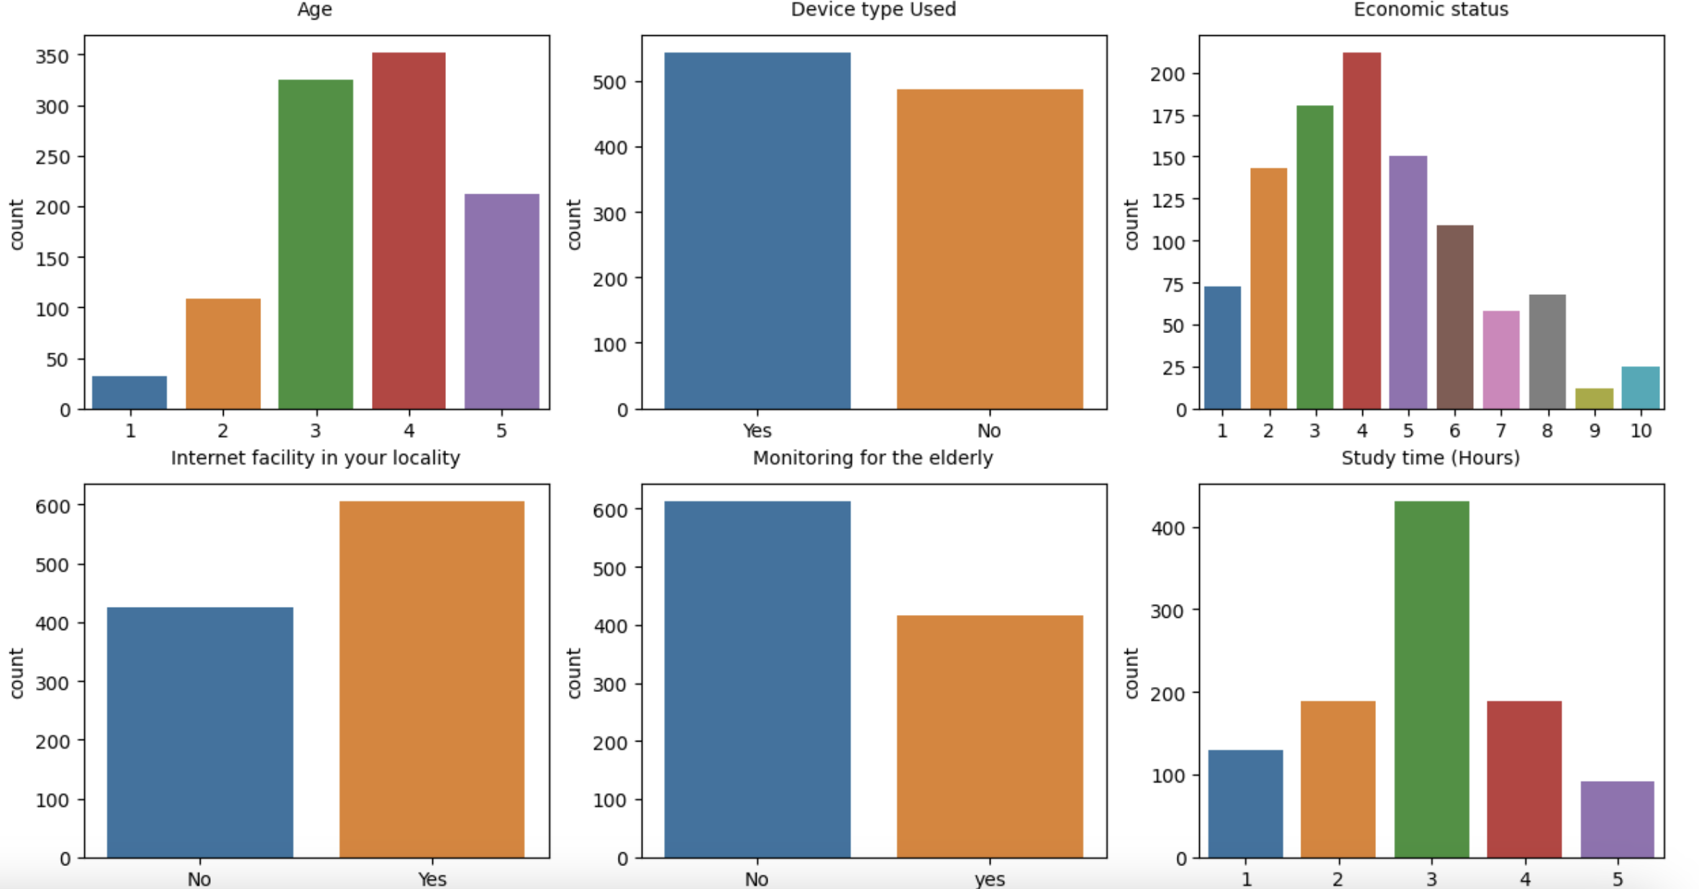
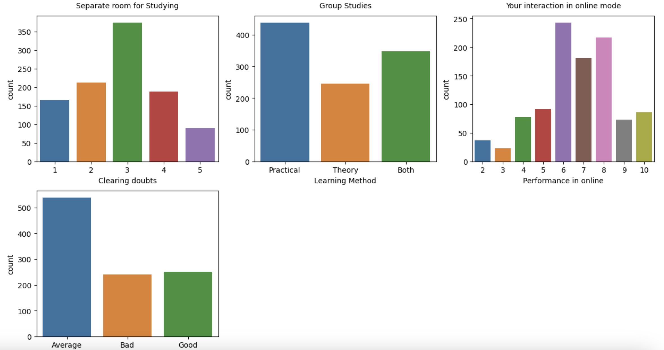
There are more males than females in this dataset with an age distribution ranging from 9 to 40 years. The majority live in the city area and have a moderate financial condition. A large number are in a graduate program. We also can see that most of the study has around 3 a 4 hours of studying and some of them have a separate room for studying. These students mostly use laptops to do online learning.
In [18]:
i = 1
plt.figure(figsize = (15,25))
for feature in df3:
plt.subplot(6,3,i)
sns.countplot(x = feature , hue='Level of Satisfaction', data = df3)
i +=1
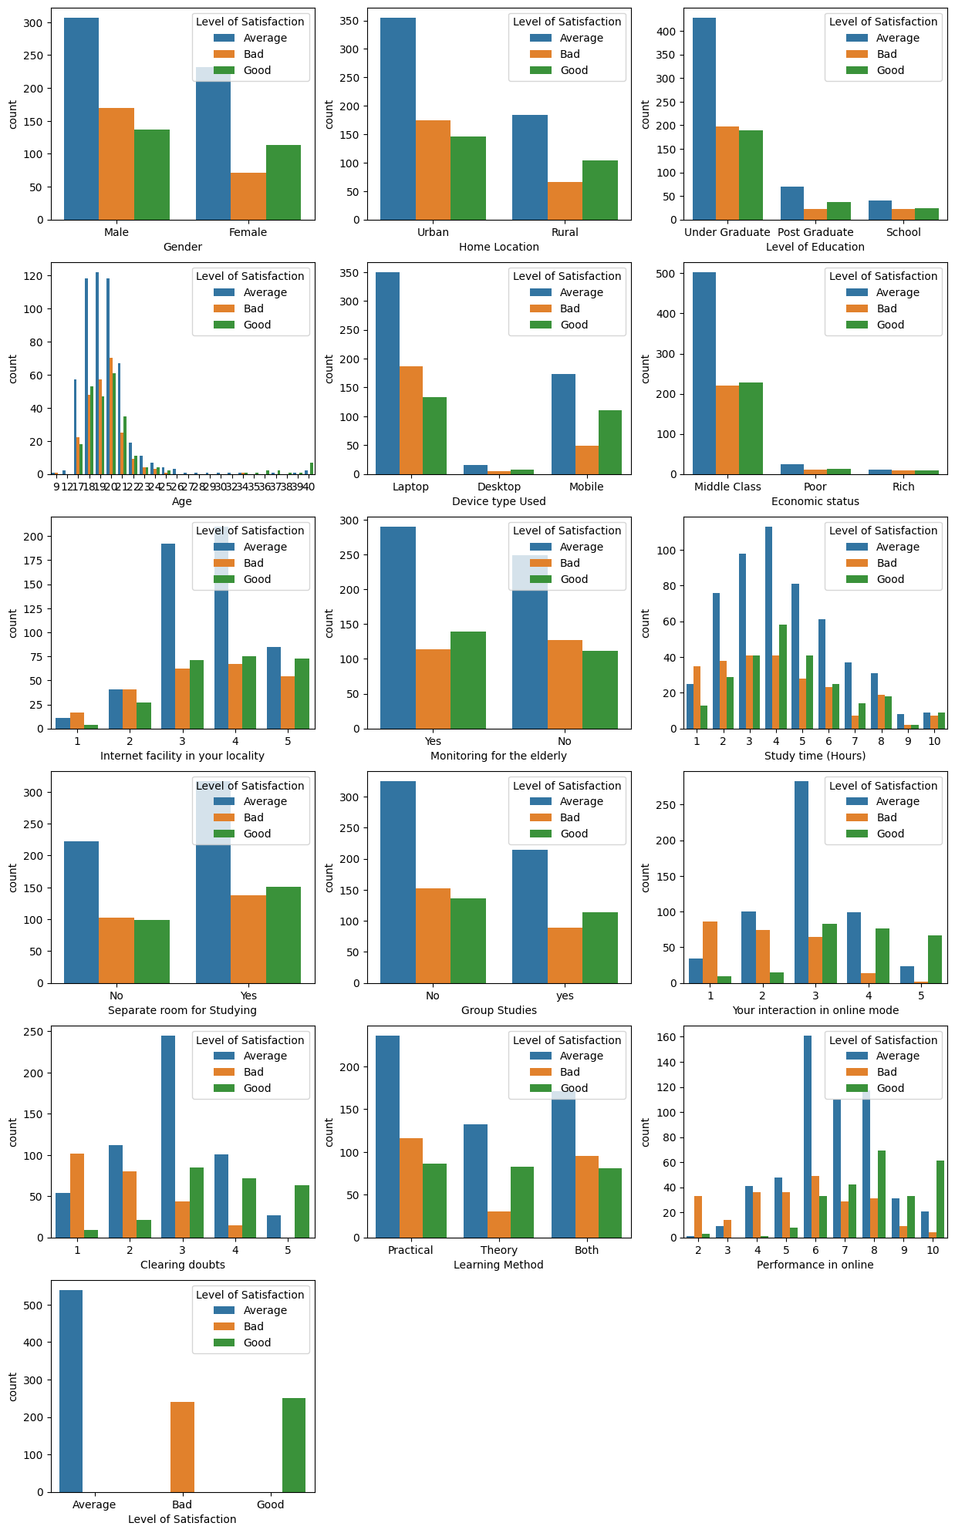
Now I will check some correlation between some features to understand our dataset.
In [19]:
pd.crosstab(df3["Home Location"], df3["Economic status"]).style.background_gradient(cmap='Blues')
Out[19]:
Economic status | Middle Class | Poor | Rich
Home Location
Rural | 316 | 35 | 3
Urban | 635 | 14 | 27
Here we can see that the majority of students are from urban areas and middle class.
Below I will check the correlation between the level of satisfaction and online performance, and we can see that the majority of students who performed well online have average satisfaction.
In [20]:
pd.crosstab(df3["Performance in online"], df3["Level of Satisfaction"]).style.background_gradient(cmap='Blues')
Out[20]:
Level of Satisfaction | Average | Bad | Good
Performance in online
2 | 1 | 33 | 3
3 | 9 | 14 | 0
4 | 41 | 36 | 1
5 | 48 | 36 | 8
6 | 161 | 49 | 33
7 | 110 | 29 | 42
8 | 117 | 31 | 69
9 | 31 | 9 | 33
10 | 21 | 4 | 61
Below we can see that the more you interact in classes, the better your performance online.
In [21]:
pd.crosstab(df3["Your interaction in online mode"], df3["Performance in online"]).style.background_gradient(cmap='Blues')
Out[21]:
Performance in online | 2 | 3 | 4 | 5 | 6 | 7 | 8 | 9 | 10
Your interaction in online mode
1 | 31 | 10 | 20 | 14 | 23 | 9 | 18 | 1 | 3
2 | 4 | 9 | 29 | 31 | 46 | 28 | 25 | 11 | 6
3 | 2 | 4 | 24 | 43 | 140 | 103 | 85 | 17 | 13
4 | 0 | 0 | 5 | 3 | 29 | 35 | 74 | 26 | 17
5 | 0 | 0 | 0 | 1 | 5 | 6 | 15 | 18 | 47
In [22]:
pd.crosstab(df3["Your interaction in online mode"], df3["Level of Satisfaction"]).style.background_gradient(cmap='Blues')
Out[22]:
Level of Satisfaction | Average | Bad | Good
Your interaction in online mode
1 | 34 | 86 | 9
2 | 100 | 74 | 15
3 | 283 | 65 | 83
4 | 99 | 14 | 76
5 | 23 | 2 | 67
In the next correlation we can see that even though there are fewer women in this dataset, they have greater interaction in classes.
In [23]:
pd.crosstab([df3["Gender"], df3["Clearing doubts"]], df3["Level of Satisfaction"]).style.background_gradient(cmap='Blues')
Out[23]:
 | Level of Satisfaction | Average | Bad | Good
Gender | Clearing doubts
Female | 1 | 22 | 28 | 1
Female | 2 | 44 | 24 | 8
Female | 3 | 108 | 14 | 38
Female | 4 | 43 | 5 | 32
Female | 5 | 15 | 0 | 34
Male | 1 | 32 | 74 | 8
Male | 2 | 68 | 56 | 13
Male | 3 | 137 | 30 | 47
Male | 4 | 58 | 10 | 40
Male | 5 | 12 | 0 | 29
I will check if there are any outliers in the Satisfaction Level and Performance features online, if so I will drop them for better accuracy in my model.
In [24]:
sns.boxplot(x='Level of Satisfaction', y='Performance in online', data=df3)
Out[24]:
<Axes: xlabel='Level of Satisfaction', ylabel='Performance in online'>
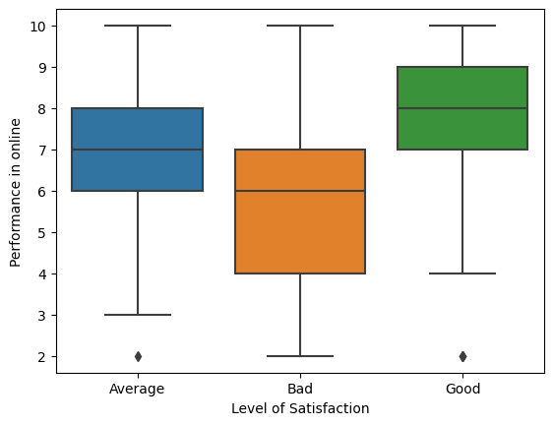
Above we can see that there are some outliers in the average and good satisfaction, I will check how many there are and see if it is possible to drop them. Calculate the interquartile range (IQR) of the Performance in oline
In [25]:
Q1 = df3['Performance in online'].quantile(0.25)
Q3 = df3['Performance in online'].quantile(0.75)
IQR = Q3 - Q1
Set lower and upper limits for outliers
In [26]:
lower_bound = Q1 - 1.5 * IQR
upper_bound = Q3 + 1.5 * IQR
In [27]:
outliers_before = df3[(df3['Performance in online'] < lower_bound) | (df3['Performance in online'] > upper_bound)].shape[0]
print("Quantity of outliers:", outliers_before)
Quantity of outliers: 37
In [28]:
37*100/1030
Out[28]:
3.592233009708738
Those 37 rows represent only 3% of my dataset, so I'll drop then.
In [29]:
df4= df3[(df3['Performance in online'] >= lower_bound) & (df3['Performance in online'] <= upper_bound)]
In [30]:
df4.shape
Out[30]:
(993, 16)
I will split two different datasets, one with the target as satisfaction level and one with online performance as the target.
In [31]:
df4['Level of Satisfaction'].value_counts()
Out[31]:
Level of Satisfaction
Average 538
Good 247
Bad 208
Name: count, dtype: int64
I will copy my df4 dataset to a new one to start building the dataset to apply the machine learning models
In [32]:
df_1=df4
Encoding Ordinal and Nominal Variable to check the correlation with the target
In [33]:
from sklearn.preprocessing import LabelEncoder
enc = LabelEncoder()

# List of columns to encode
columns_to_encode = ['Gender', 'Home Location', 'Level of Education', 'Device type Used',
'Economic status', 'Monitoring for the elderly', 'Separate room for Studying',
'Group Studies', 'Learning Method', 'Level of Satisfaction']

# Create a LabelEncoder instance
enc = LabelEncoder()

# Apply encoding to multiple columns
df_1_encoded = df_1.apply(lambda col: enc.fit_transform(col) if col.name in columns_to_encode else col)

# then assign it to the original dataframe
df_1 = df_1_encoded
In [34]:
df_1.head()
Out[34]:
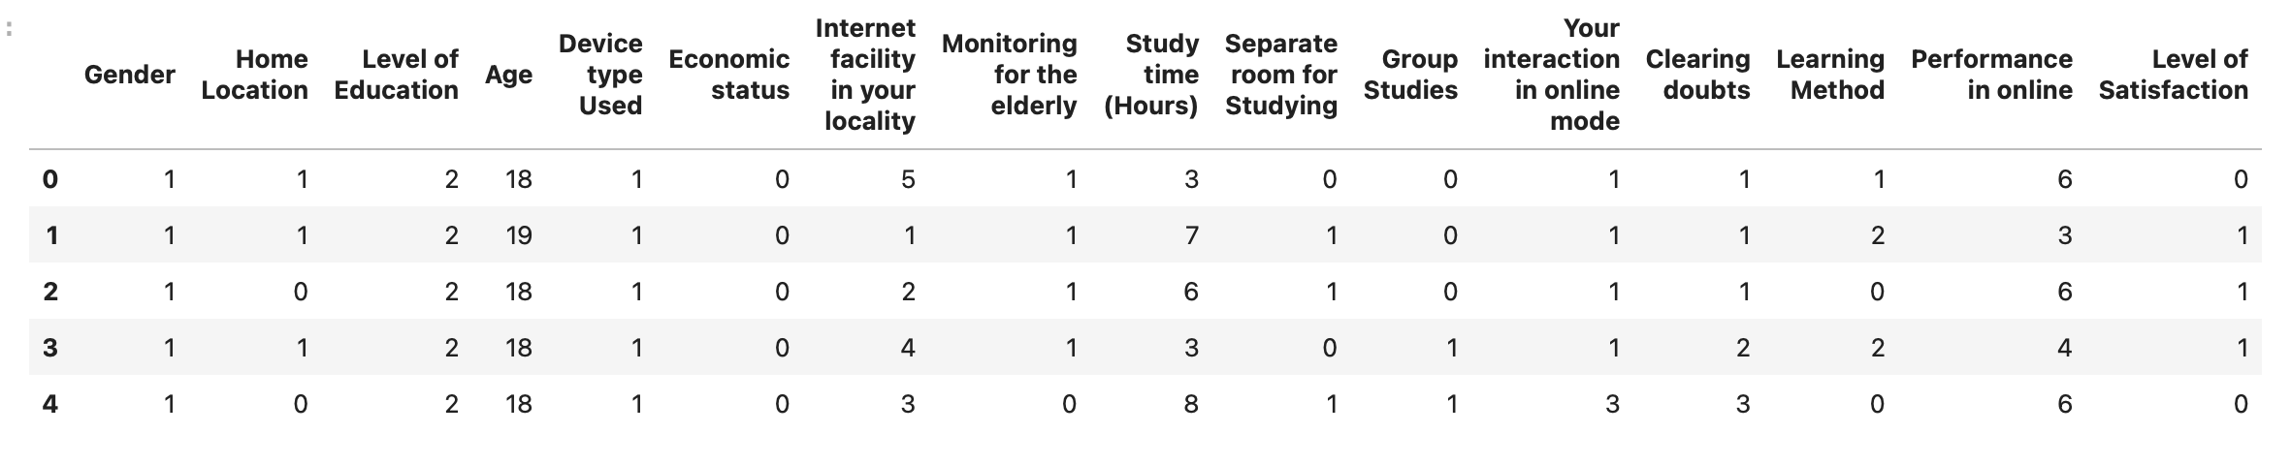Now that my entire dataframe is in numeric features, I will again check the level of correlation between the features with my target (Satisfaction Level) and eliminate the columns with the least correlation
In [35]:
df_1.corr().style.background_gradient(cmap="Blues")
Out[35]:
 | Gender | Home Location | Level of Education | Age | Device type Used | Economic status | Internet facility in your locality | Monitoring for the elderly | Study time (Hours) | Separate room for Studying | Group Studies | Your interaction in online mode | Clearing doubts | Learning Method | Performance in online | Level of Satisfaction
Gender | 1.000000 | -0.070334 | -0.005586 | -0.039882 | -0.056213 | -0.033186 | -0.062541 | -0.023093 | -0.093936 | 0.023048 | -0.062208 | -0.111571 | -0.096775 | -0.135927 | -0.068411 | -0.003517
Home Location | -0.070334 | 1.000000 | 0.017156 | 0.002402 | -0.268064 | -0.025143 | 0.274978 | 0.012502 | -0.061031 | 0.090919 | 0.032850 | -0.080950 | -0.100838 | -0.130840 | -0.024737 | -0.048942
Level of Education | -0.005586 | 0.017156 | 1.000000 | -0.343715 | -0.019565 | 0.031824 | 0.066041 | 0.006984 | 0.054382 | 0.016111 | -0.073161 | -0.048474 | -0.040592 | -0.029481 | 0.019420 | -0.024272
Age | -0.039882 | 0.002402 | -0.343715 | 1.000000 | -0.034954 | -0.004241 | 0.071128 | -0.042263 | 0.000833 | 0.022952 | 0.103821 | 0.170093 | 0.122013 | -0.129896 | 0.108653 | 0.119656
Device type Used | -0.056213 | -0.268064 | -0.019565 | -0.034954 | 1.000000 | 0.019539 | -0.242119 | -0.041488 | -0.047583 | -0.201094 | -0.009733 | 0.098302 | 0.125376 | 0.150220 | 0.032529 | 0.072741
Economic status | -0.033186 | -0.025143 | 0.031824 | -0.004241 | 0.019539 | 1.000000 | 0.064817 | -0.041812 | -0.013367 | -0.062235 | -0.006949 | 0.066189 | 0.062739 | 0.008255 | 0.061906 | 0.042731
Internet facility in your locality | -0.062541 | 0.274978 | 0.066041 | 0.071128 | -0.242119 | 0.064817 | 1.000000 | 0.013399 | -0.014561 | 0.224949 | 0.040367 | 0.183094 | 0.141300 | -0.062630 | 0.241856 | 0.051670
Monitoring for the elderly | -0.023093 | 0.012502 | 0.006984 | -0.042263 | -0.041488 | -0.041812 | 0.013399 | 1.000000 | 0.091915 | 0.041993 | 0.079262 | 0.094964 | 0.102562 | 0.029756 | 0.069674 | 0.010382
Study time (Hours) | -0.093936 | -0.061031 | 0.054382 | 0.000833 | -0.047583 | -0.013367 | -0.014561 | 0.091915 | 1.000000 | 0.094952 | 0.014164 | 0.151416 | 0.173067 | -0.011038 | 0.138738 | 0.014186
Separate room for Studying | 0.023048 | 0.090919 | 0.016111 | 0.022952 | -0.201094 | -0.062235 | 0.224949 | 0.041993 | 0.094952 | 1.000000 | 0.080831 | 0.072280 | 0.062687 | -0.053571 | 0.079522 | 0.013973
Group Studies | -0.062208 | 0.032850 | -0.073161 | 0.103821 | -0.009733 | -0.006949 | 0.040367 | 0.079262 | 0.014164 | 0.080831 | 1.000000 | 0.104032 | 0.112221 | -0.033678 | 0.105800 | 0.043872
Your interaction in online mode | -0.111571 | -0.080950 | -0.048474 | 0.170093 | 0.098302 | 0.066189 | 0.183094 | 0.094964 | 0.151416 | 0.072280 | 0.104032 | 1.000000 | 0.701974 | 0.045361 | 0.495626 | 0.226388
Clearing doubts | -0.096775 | -0.100838 | -0.040592 | 0.122013 | 0.125376 | 0.062739 | 0.141300 | 0.102562 | 0.173067 | 0.062687 | 0.112221 | 0.701974 | 1.000000 | 0.038877 | 0.509942 | 0.209731
Learning Method | -0.135927 | -0.130840 | -0.029481 | -0.129896 | 0.150220 | 0.008255 | -0.062630 | 0.029756 | -0.011038 | -0.053571 | -0.033678 | 0.045361 | 0.038877 | 1.000000 | -0.011043 | 0.023951
Performance in online | -0.068411 | -0.024737 | 0.019420 | 0.108653 | 0.032529 | 0.061906 | 0.241856 | 0.069674 | 0.138738 | 0.079522 | 0.105800 | 0.495626 | 0.509942 | -0.011043 | 1.000000 | 0.279496
Level of Satisfaction | -0.003517 | -0.048942 | -0.024272 | 0.119656 | 0.072741 | 0.042731 | 0.051670 | 0.010382 | 0.014186 | 0.013973 | 0.043872 | 0.226388 | 0.209731 | 0.023951 | 0.279496 | 1.000000
Deleting columns with the least relationship to my target
In [36]:
df_1=df_1.drop(columns=['Home Location','Level of Education','Device type Used','Economic status','Monitoring for the elderly','Separate room for Studying','Learning Method'])
In [37]:
df_1.head(1)
Out[37]:

Machine Learning
First I will apply normalization and standardization before building ML models.
In [38]:
from sklearn.preprocessing import Normalizer
from sklearn.preprocessing import StandardScaler

Normalization
Normalization refers to the process of rescaling the features of a dataset to have similar ranges or scales
In [39]:
normalizer = Normalizer()
X_normalized = pd.DataFrame(normalizer.fit_transform(df_1.drop('Level of Satisfaction', axis=1)), columns=df_1.columns[:-1])

Standardization
Transform features in one way that they going to have a mean of 0 and a standard deviation of 1.
In [40]:
scaler = StandardScaler()
X_scaled = pd.DataFrame(scaler.fit_transform(df_1.drop('Level of Satisfaction', axis=1)), columns=df_1.columns[:-1])

Building machine learning models and comparing the results
In [41]:
from sklearn.metrics import accuracy_score, precision_score, recall_score, f1_score, confusion_matrix
I will define some 'python user-defined functions' to build each model and compare their results.
In [42]:
def fit_predict_score(Model, X_train, y_train, X_test, y_test):
"""Fit the model of your choice, predict for test data, and returns classification metrics."""
model = Model
model.fit(X_train, y_train)
y_pred = model.predict(X_test)
train_score = model.score(X_train, y_train)
test_score = model.score(X_test, y_test)
return train_score, test_score, precision_score(y_test, y_pred, average='micro'), recall_score(y_test, y_pred, average='micro'), f1_score(y_test, y_pred, average='micro')

def model_comparison(X, y):
"""Creates a DataFrame comparing Logistic Regression, K-Nearest Neighbors, Decision Tree,
Random Forest, Support Vector Machines"""

X_train, X_test, y_train, y_test = train_test_split(X, y, test_size=0.30, random_state=42)

lr_train_score, lr_test_score, lr_pr, lr_re, lr_f1 = fit_predict_score(LogisticRegression(), X_train, y_train, X_test, y_test)
knn_train_score, knn_test_score, knn_pr, knn_re, knn_f1 = fit_predict_score(KNeighborsClassifier(), X_train, y_train, X_test, y_test)
dtc_train_score, dtc_test_score, dtc_pr, dtc_re, dtc_f1 = fit_predict_score(DecisionTreeClassifier(), X_train, y_train, X_test, y_test)
rfc_train_score, rfc_test_score, rfc_pr, rfc_re, rfc_f1 = fit_predict_score(RandomForestClassifier(), X_train, y_train, X_test, y_test)
svc_train_score, svc_test_score, svc_pr, svc_re, svc_f1 = fit_predict_score(SVC(), X_train, y_train, X_test, y_test)

models = ['Logistic Regression', 'K-Nearest Neighbors', 'Decision Tree', 'Random Forest', 'Support Vector Machines']
train_score = [lr_train_score, knn_train_score, dtc_train_score, rfc_train_score, svc_train_score]
test_score = [lr_test_score, knn_test_score, dtc_test_score, rfc_test_score, svc_test_score]
precision = [lr_pr, knn_pr, dtc_pr, rfc_pr]
recall = [lr_re, knn_re, dtc_re, rfc_re, svc_re]
f1 = [lr_f1, knn_f1, dtc_f1, rfc_f1, svc_f1]

model_comparison = pd.DataFrame(data=[models, train_score, test_score, precision, recall, f1]).T.rename({0: 'Model',
1:'Training Score',
2: 'Test Score (Accuracy)',
3: 'Precision',
4: 'Recall',
5: 'F1 Score'
}, axis=1)

return model_comparison
My next step is to divide the data into “attributes” and “labels”. Attributes are the independent variables while labels are dependent variables whose values are to be predicted.
In [43]:
X = df_1.drop(['Level of Satisfaction'], axis=1)
y = df_1['Level of Satisfaction']
After defining function, X and y, I'll will build the models with normal default dataframe, normalized dataframe and standardized dataframe.
Then we will see the scores for these 3 methods
I'll import some machine learning libraries.
In [44]:
from sklearn.linear_model import LogisticRegression
from sklearn.neighbors import KNeighborsClassifier
from sklearn.discriminant_analysis import LinearDiscriminantAnalysis
from sklearn.svm import SVC
from sklearn.ensemble import RandomForestClassifier
from sklearn.tree import DecisionTreeClassifier
In [45]:
print("Default DataFrame:")
display(model_comparison(X, y))
print('-'*40)
print("\nNormalized DataFrame:")
display(model_comparison(X_normalized, y))
print('-'*40)
print("\nStandardized DataFrame:")
display(model_comparison(X_scaled, y))
Default DataFrame:
 | Model | Training Score | Test Score (Accuracy) | Precision | Recall | F1 Score
0 | Logistic Regression | 0.648921 | 0.573826 | 0.573826 | 0.573826 | 0.573826
1 | K-Nearest Neighbors | 0.692086 | 0.580537 | 0.580537 | 0.580537 | 0.580537
2 | Decision Tree | 0.997122 | 0.550336 | 0.550336 | 0.550336 | 0.550336
3 | Random Forest | 0.997122 | 0.600671 | 0.600671 | 0.600671 | 0.600671
4 | Support Vector Machines | 0.584173 | 0.516779 | None | 0.516779 | 0.516779
----------------------------------------

Normalized DataFrame:
 | Model | Training Score | Test Score (Accuracy) | Precision | Recall | F1 Score
0 | Logistic Regression | 0.559712 | 0.496644 | 0.496644 | 0.496644 | 0.496644
1 | K-Nearest Neighbors | 0.67482 | 0.567114 | 0.567114 | 0.567114 | 0.567114
2 | Decision Tree | 0.997122 | 0.536913 | 0.536913 | 0.536913 | 0.536913
3 | Random Forest | 0.997122 | 0.580537 | 0.580537 | 0.580537 | 0.580537
4 | Support Vector Machines | 0.561151 | 0.496644 | None | 0.496644 | 0.496644
----------------------------------------

Standardized DataFrame:
 | Model | Training Score | Test Score (Accuracy) | Precision | Recall | F1 Score
0 | Logistic Regression | 0.651799 | 0.577181 | 0.577181 | 0.577181 | 0.577181
1 | K-Nearest Neighbors | 0.699281 | 0.587248 | 0.587248 | 0.587248 | 0.587248
2 | Decision Tree | 0.997122 | 0.54698 | 0.54698 | 0.54698 | 0.54698
3 | Random Forest | 0.997122 | 0.604027 | 0.604027 | 0.604027 | 0.604027
4 | Support Vector Machines | 0.707914 | 0.580537 | None | 0.580537 | 0.580537
As the dataset is imbalanced, I will apply the SMOTE function that creates synthetic data to see if I will have better accuracy.
In [46]:
from imblearn.over_sampling import SMOTE
In [47]:
sm = SMOTE(random_state=1)
X_resampled, y_resampled = sm.fit_resample(X, y)
In [48]:
print("SMOTE applied DataFrame:")
display(model_comparison(X_resampled, y_resampled))
SMOTE applied DataFrame:
 | Model | Training Score | Test Score (Accuracy) | Precision | Recall | F1 Score
0 | Logistic Regression | 0.620018 | 0.610309 | 0.610309 | 0.610309 | 0.610309
1 | K-Nearest Neighbors | 0.772365 | 0.686598 | 0.686598 | 0.686598 | 0.686598
2 | Decision Tree | 0.9938 | 0.643299 | 0.643299 | 0.643299 | 0.643299
3 | Random Forest | 0.9938 | 0.727835 | 0.727835 | 0.727835 | 0.727835
4 | Support Vector Machines | 0.629761 | 0.618557 | None | 0.618557 | 0.618557
We can see that the results are better.
I'll have a look at the K-Nearest Neighbors to apply the hyperparameters
I'll start splitting the data into training, and testing.
The training set is a portion of the dataset that is used to train the machine learning model
The testing set is another portion of the dataset that is held out and not used during the training process.
I checked the test_size as 20%, 25% and 30% and got the best accuracy with 25%, so I will follow the model with that percentage.
In [49]:
from sklearn.model_selection import train_test_split
X_train, X_test, y_train, y_test = train_test_split(X_resampled, y_resampled, test_size = 0.25, random_state = 42)
In [50]:
X_train.shape, X_test.shape, y_train.shape, y_test.shape
Out[50]:
((1210, 8), (404, 8), (1210,), (404,))
I'll create KNN Classifier and than train the model and predict the response
In [51]:
kNN = KNeighborsClassifier(n_neighbors = 3)
kNN.fit(X_train, y_train)
y_pred = kNN.predict(X_test)
In [52]:
from sklearn import metrics
print( "Accuracy: {:.2f}".format(metrics.accuracy_score(y_test, y_pred)) )
Accuracy: 0.74

Hyperparameters
Hyperparameters are settings that are not learned by the model during training, they control broader aspects of the training and modelling process.
Hyperparameters are used by the learning algorithm when it is learning, but are not part of the resulting model. At the end of the learning process, we have the parameters of the trained model, which is effectively what we call a model. The hyperparameters used during training are not part of this model. We cannot, for example, know which hyperparameter values ​​were used to train a model from the model itself, we only know the model parameters that were learned. (Nyuytiymbiy)
I will apply the hyperparameter in my kNN ML to check how it will react.
In [53]:
import numpy as np
neighbors = np.arange(1, 13)
train_accuracy = np.zeros(len(neighbors))
test_accuracy = np.zeros(len(neighbors))
In [54]:
for i, k in enumerate(neighbors):
kNN = KNeighborsClassifier(n_neighbors = k)

kNN.fit(X_train, y_train)
train_accuracy[i] = kNN.score(X_train, y_train)

test_accuracy[i] = kNN.score(X_test, y_test)
And now I'll plot it

In [55]:
import matplotlib.pyplot as plt

plt.figure(figsize = (10, 5))
plt.title('KNN accuracy with varying number of neighbors', fontsize = 20)
plt.plot(neighbors, test_accuracy, label = 'Testing Accuracy')
plt.plot(neighbors, train_accuracy, label = 'Training accuracy')
plt.legend(prop={'size': 20})
plt.xlabel('Number of neighbors', fontsize = 20)
plt.ylabel('Accuracy', fontsize = 20)
plt.xticks(fontsize = 20)
plt.yticks(fontsize = 20)
plt.show()
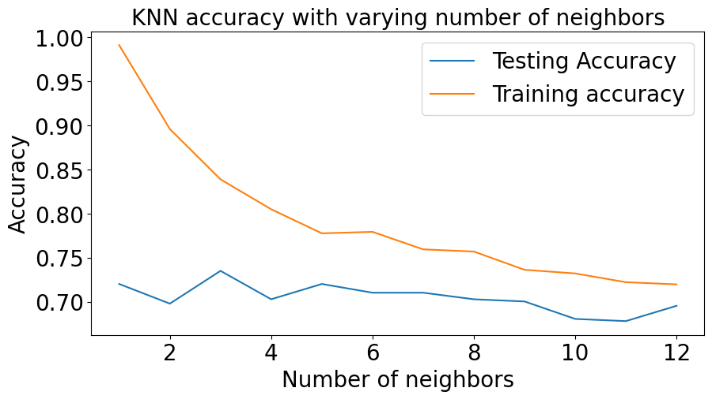

Conclusion
After all the exploratory analysis we can conclude that your social class or where you live is not a relevant factor, neither your gender, but your interaction and questioning during the class positively influence your grade and the level of satisfaction in online classes. With regard to machine learning methods, I compared the original dataframe, normalized it, then standardized it, and lastly, as I noticed that the dataset was imbalanced during the analysis, I applied the SMOTE method and saw an improvement in the results of the correlation between the models. I concluded that the models with the best accuracy for ML are K-Nearest Neighbors and Support Vector Machines after applying SMOTE. One point to note regarding Decision Tree and Random Forest, both had good accuracy, but the training score is very high, which can be the result of overfitting (In machine learning, overfitting occurs when an algorithm fits too closely or even exactly to its training data, resulting in a model that can't make accurate predictions or conclusions from any data other than the training data. (IBM, "What Is Overfitting? | IBM")) so it wouldn't be the best choice for the model.
GitHub link: https://github.com/FroelichGiovana/CA1---Machine-Learning---Giovana-Froelich
References
IBM. “What Is Exploratory Data Analysis? | IBM.” Www.ibm.com, 2020, IBM. “What Is Exploratory Data Analysis? | IBM.” Www.ibm.com, 2020, www.ibm.com/topics/exploratory-data-analysis.

Nyuytiymbiy, Kizito. “Parameters and Hyperparameters in Machine Learning and Deep Learning.” Medium, 5 Apr. 2021, towardsdatascience.com/parameters-and-hyperparameters-aa609601a9ac.

---. “What Is Overfitting? | IBM.” Www.ibm.com, 2023, www.ibm.com/topics/overfitting.

“ONLINE EDUCATION SYSTEM.” Www.kaggle.com, Oct. 2023, www.kaggle.com/datasets/bhavyajha14/online-educations-system/data. Accessed 21 Apr. 2024.

